DESCRIPTION OF PAINT SAVER FUNNEL
Client: Hendrik Willem Engelbrecht
ID: 6910125032080
083 707 3691
014 777 3120
henk.engelbrecht@angloamerican.com
Problem Statement:
When pouring from a 5 liter paint container it is always a lot waste. Paint typically runs from the side of the container and some clog up the groove of the lid. To remove this you need to wipe it out and some paint runs back into the container, but a lot also pours down the side of the container. When the lid is to be closed again, the dried paint in the groove prevents the lid from properly entering its original position again. Hence the lid no longer seals properly and over a period of time the paint in the container hardens and can no longer be used.
Therefore, the problem addressed with the device as proposed is to enable pouring of paint from a container without spilling or damaging the sealing properties of the container.
Invention:
The invention is a funnel with a groove similar to that of the lid. The invention consists of a ring that fit precisely into the groove of the container where the lid normally sits. On this ring a funnel is connected which will guide the paint out of the container. The funnel is only half a cone so that you can see the paint being poured and also to save manufacturing material. When the container is again in its normal position the paint can flow back from the funnel with no paint contaminating the container’s groove.
Pin the design provision was made for both the plastic and tin containers that are currently on the market.
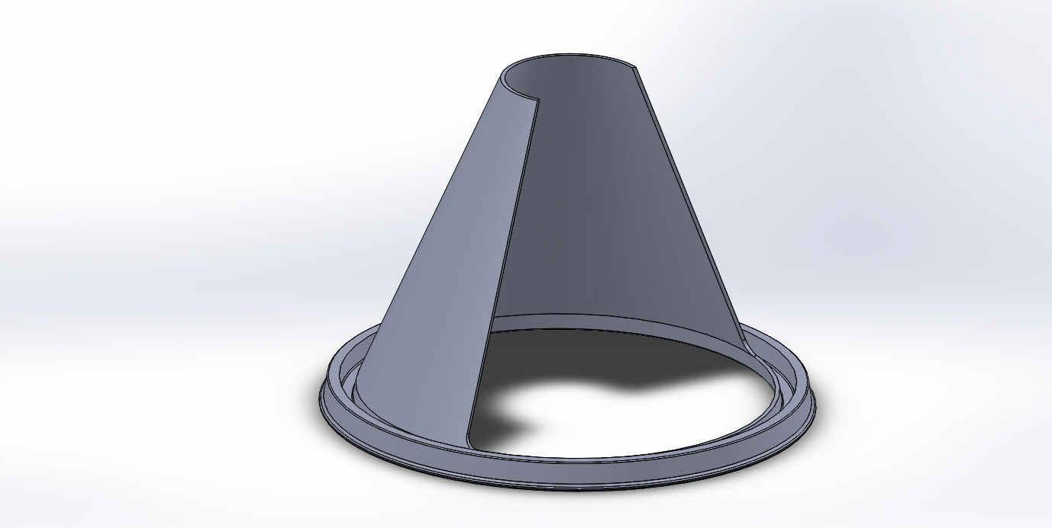
Design of Funnel for Plastic container
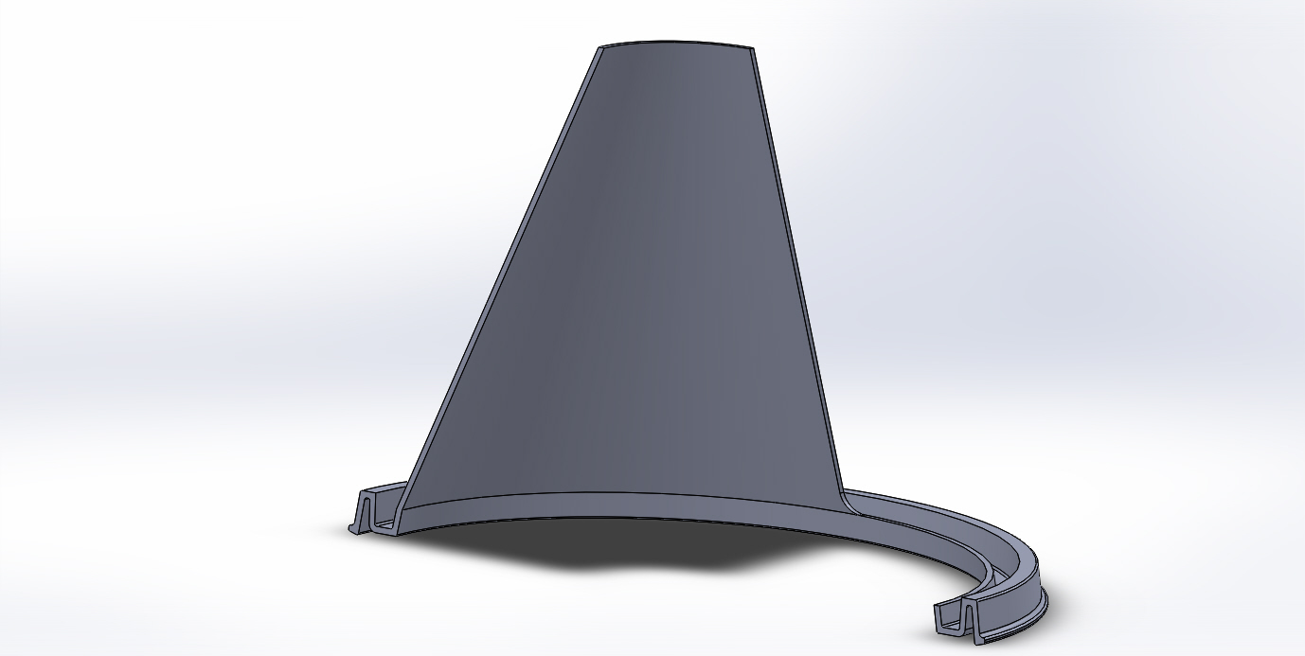
Section of Design of Funnel for Plastic container
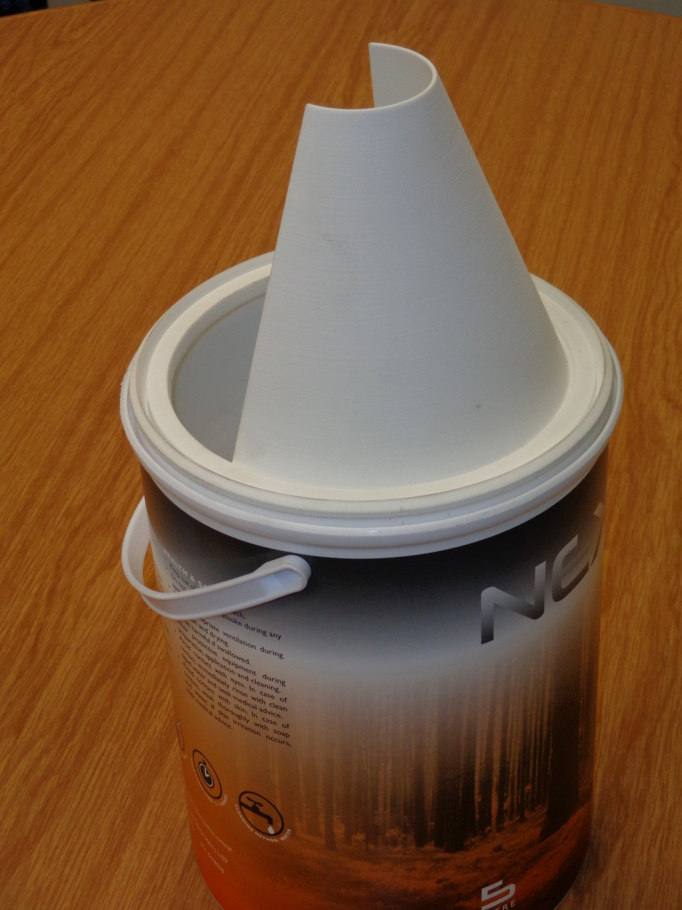
Plastic container with funnel in position
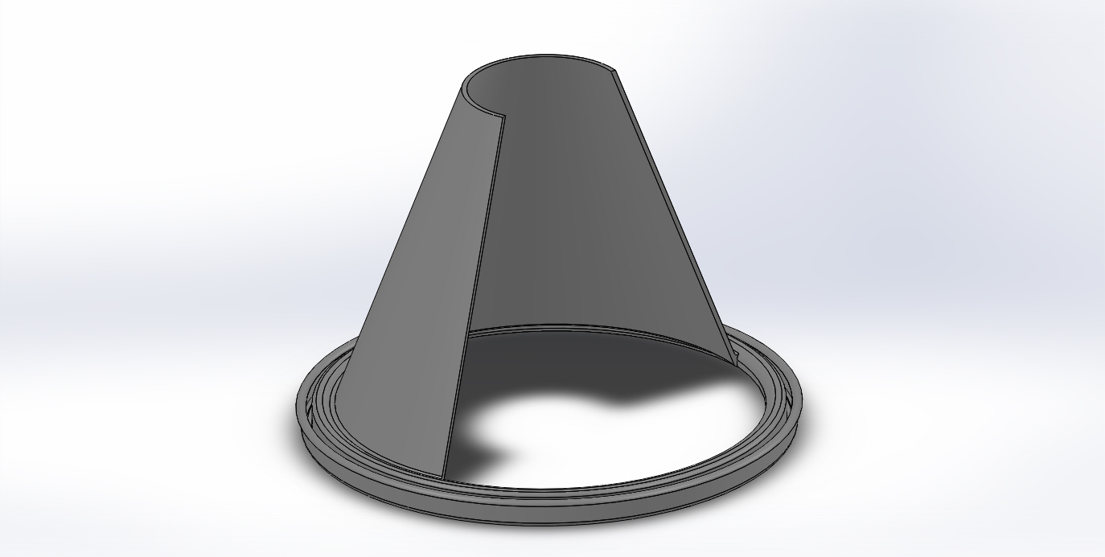
Design of Tin Can Funnel
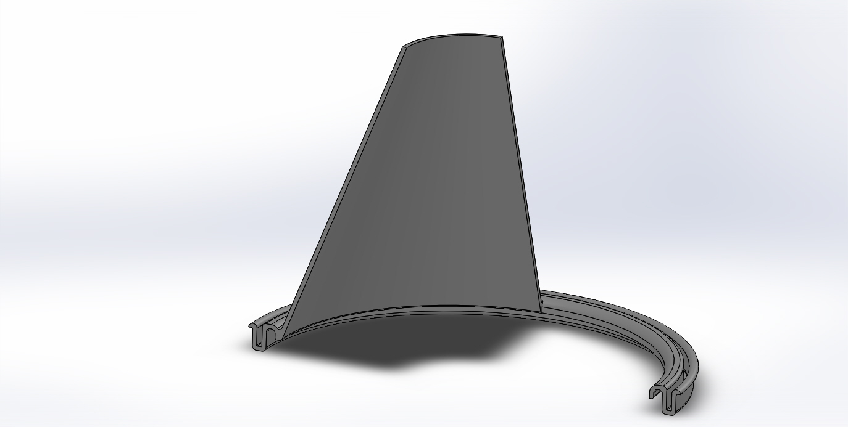
Section of Design of Tin Can Funnel
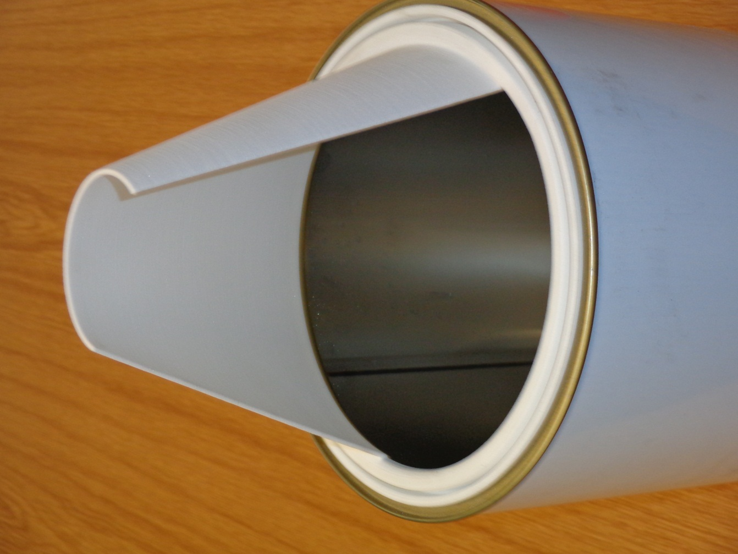
Tin container with funnel in position
