POSSIBLE DESIGN REGISTRATION - DESCRIPTION OF LIQUID SPOUT
Client: Ockert Nell
082 561 3066
onell@sparta.co.za

Problem Statement:
In those agricultural or industrial cases where any fluid is to be decanted from a relatively large container (say 20 l to 210 l) it is always a problem not to waste some of the contents due to splashing since the hole of the decanter is too big, or because the container is difficult to handle.
Invention:
This invention involves a liquid spout with which you can safely pour liquid out of a 20 to 200 litre container without spilling. It consists of a pipe, bent at an angle and then reduced to a 48 mm diameter pipe. The large end of this pipe is to be fitted onto the opening of the decanting container whilst a standard screw thread, which is normally used on 20 l plastic container caps, is provided on the small end of the pipe. With a cap in place on this thread no spillage can occur, whilst it will ensure that no foreign objects enter the container from which you are decanting.
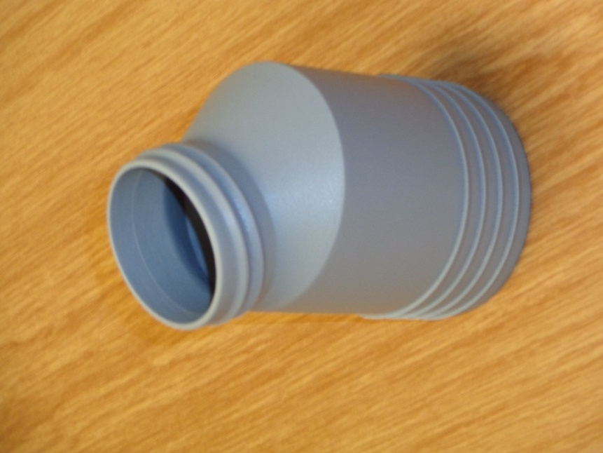
Figure 1: Liquid spout.
The component shown above is the main part of the invention, referred to as the “liquid spout”.
The beige device fitted onto the bottom of the spout shown in Figure 2 below is a standard rubber water seal from a toilet cistern. There was no need to develop this due to the fact that it is a standard part and available already in the market. The sharp edges on the bottom of the spout are very important to keep the rubber seal in place.
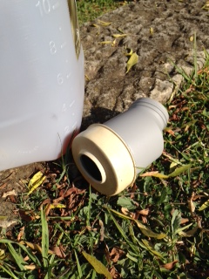
Figure 2: A liquid spout fitted with a cistern water seal.
The thread on the small diameter of the spout is the same as on a normal 20 l container. Therefore the cap from a 20 l container can just be transferred to the spout when you want to close it off again.
Novelty Claim:
The novelty is that it works on various diameters of container openings. No other device that is available can handle different opening sizes. The only other product available for this purpose is a funnel. Some containers have built-in breather pipes. However, this makes the manufacture of the container very expensive. It is also only available for 5 and 20 l containers.
